**Modifying Teacher Capabilities**

Go to

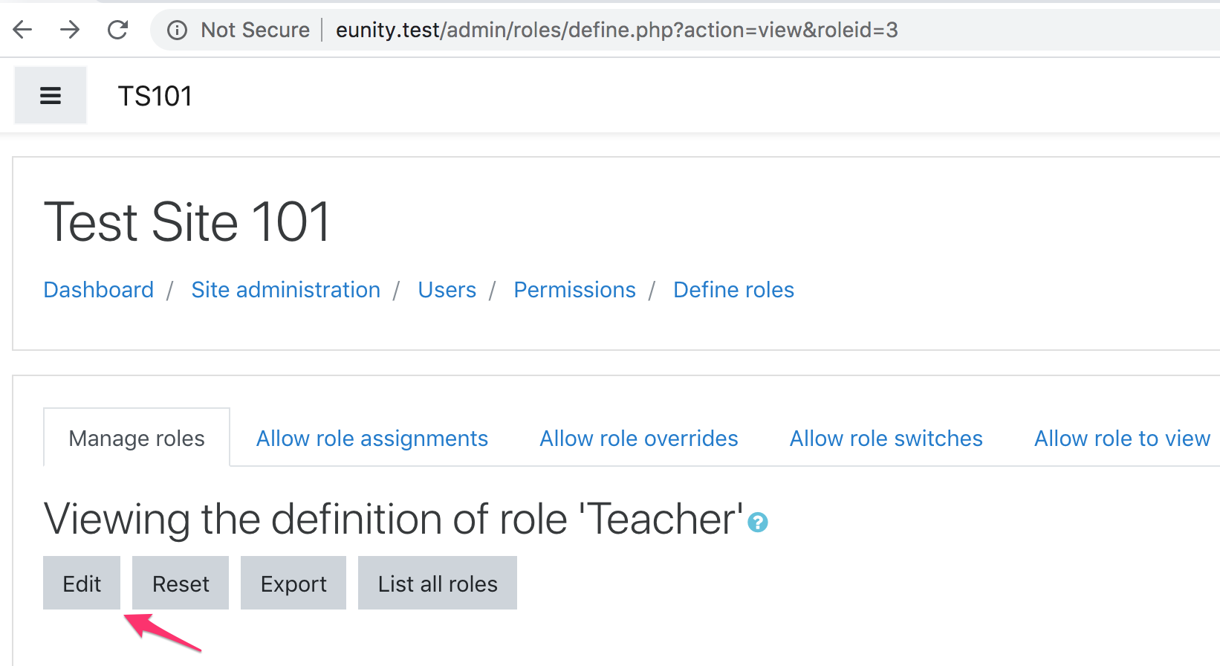

Click the Edit button

Search/scroll to Link Proxy, select the Allow checkbox



Check that when teachers create a link it includes the hash as expected.